

**FINAL YEAR PROJECT REPORT**

**BS (COMPUTER SCIENCE)**

**AUTOMATIC COURSE SCHEDULER**

**SUBMITTED BY:**

ABDUL MAJID 51347

MUHAMMAD GHULAM HAMZA 51228

TAHA MIR 50560

**COORDINATOR:**

DR. AARIJ MAHMOOD HUSSAAN

**FACULTY OF ENGINEERING, SCIENCE AND TECHNOLOGY**

**IQRA UNIVERSITY, KARACHI**

**MARCH 2024**



**FACULTY OF ENGINEERING, SCIENCE AND TECHNOLOGY**

**DEPARTMENT OF COMPUTER SCIENCE**

**FINAL YEAR PROJECT REPORT**

**BACHELOR OF COMPUTER SCIENCE**

ABDUL MAJID 51347

MUHAMMAD GHULAM HAMZA 51228

TAHA MIR 50560

**PROJECT:**

**AUTOMATIC COURSE SCHEDULER**

**SUPERVISOR:**

DR. AARIJ MAHMOOD HUSSAAN

**MARCH 2024:**

**We have approved this manuscript for submission and presentation as fulfillment of Bachelor of Computer Science.**

**_______________________________**

**Project Coordinator:**

DR. AARIJ MAHMOOD HUSSAAN

**Date: _______________**

**ABSTRACT**

In today's rapidly evolving digital landscape, the intersection of technology and education holds immense promise for shaping the future of learning. Our project endeavors to harness this potential by developing a sophisticated automated course scheduling system using Python Django framework and genetic algorithm methodology. By seamlessly integrating course data, instructor preferences, and scheduling constraints, our system aims to streamline the arduous task of course scheduling in educational institutions.

The scheduler aims to efficiently allocate courses and teachers while resolving scheduling conflicts to generate optimized schedules.

The system comprises a backend implemented in Python Django, where courses, teachers, and constraints are defined, and a genetic algorithm module is employed to generate schedules. A frontend interface, built with HTML/CSS, enables users to interact with the system, input data, and view generated schedules.

Through the utilization of genetic algorithms, the scheduler optimizes schedules by iteratively evolving and selecting solutions that minimize conflicts and meet specified constraints. This approach enables the scheduler to adapt and improve its solutions over time, effectively addressing the complexities and dynamic nature of course scheduling.

The project contributes to the field of educational scheduling by providing a flexible and efficient solution that automates the scheduling process, reduces manual effort, and optimizes resource utilization. Future enhancements may include the integration of additional optimization techniques and the development of advanced scheduling features to further improve the efficiency and effectiveness of the system.

**DECLARATION**

The members of this project hereby declare that the work presented in this project, titled “Automatic Course Scheduler” builds upon existing methodologies and techniques within the field of Computer Science. While the core concepts and algorithms used in this project draw from established practices, significant modifications and enhancements have been made to address specific challenges and requirements.

One notable contribution of this project is the implementation of an error-handling function that enables users to detect and resolve conflicts in the generated schedule. This feature not only enhances the usability of the system but also adds a layer of transparency and reliability to the sc

We affirm that this project has not been previously submitted for any academic purpose. Proper acknowledgment has been given to any sources or individuals that have contributed to the development of this project, and all relevant citations and references have been included.

We acknowledge the importance of academic integrity and ethical conduct in scholarly research. Therefore, I attest that the work presented in this project represents our insights, and contributions to the field, while also building upon the collective knowledge and expertise of the academic community.

ABDUL MAJID [51347]

MUHAMMAD [51228]

TAHA AMMAR MIR [50560]

**Acknowledgments**

We would like to express our sincere gratitude to all those who have contributed to the completion of this project.

First and foremost, we extend my heartfelt appreciation to our coordinator, **Dr. Aarij Mahmood Hussaan**, for their invaluable guidance, support, and encouragement throughout this project. Their expertise, feedback, and constructive criticism have been instrumental in shaping the direction and quality of this work.

We are also indebted to the faculty and staff of Iqra University, whose dedication to academic excellence has provided me with a conducive learning environment and access to resources necessary for conducting research.

We extend our thanks to **Mrs. Saira Khurram**, **Dr. Abdul Ahad Abro**, and **Sir Israr Ali**, who generously shared their knowledge, expertise, and insights during this project. Their input and feedback have been invaluable in overcoming challenges and refining the methodologies employed.

Furthermore, we are grateful to my peers and colleagues for their camaraderie, collaboration, and moral support during the ups and downs of this endeavor. Their encouragement and solidarity have been a source of determination to see this project through to completion.

**TABLE OF CONTENTS**

**CHAPTER – 1 1****1**

* 1. **Introduction 1****1**
  2. **Problem Statement** **11**
  3. **Genetic Algorithm 12**
     1. **Initialization of Genetic Algorithm…………………………………………………………………………12**
     2. **Fitness Function ………………………………………………………………………………………………….13**
     3. **Selection in Genetic Algorithm………………………………………………………………………………13**
     4. **Crossover …………………………………………………………………………………………………………..13**
     5. **Mutation…………………………………………………………………………………………………………….14**
     6. **Replacement……………………………………………………………………………………………………….14**
     7. **Termination Condition………………………………………………………………………………………..15**
  4. **Motivation 1****5**
  5. **Objective 1****6**
  6. **Challenges 1****7**
  7. **Structure of Report 1****7**
     1. **Chapter 2: Technology Background** **18**
     2. **Chapter 3: Requirements & Methodology** **18**
     3. **Chapter 4: Project Plan & Initial Design** **18**
     4. **Chapter 5: Project Design & Development 1****8**
     5. **Chapter 6: Testing 1****8**
     6. **Chapter 7: Conclusion 1****8**

**CHAPTER – 2 1****9**

1. **Technology Background 1****9**
   1. **Background of the technology 1****9**
      1. **Visual Studio Code 1****9**
      2. **Python/Django Framework** **20**
      3. **HTML/CSS 20**

**2.3 Literature Review** **20**

**CHAPTER – 3** **21**

* 1. **Introduction** **21**
  2. **Project Plan:** **22**
  3. **Functional Requirements:** **23**
  4. **Non-Functional Requirements** **23**
  5. **Hardware Requirements:** **24**
  6. **Summary 2****5**

**CHAPTER – 4** **26**

* 1. **Introduction** **26**
  2. **Entity Relationship Diagram** **27**

**4.3 Summary 2****8**

**CHAPTER – 5 2****9**

* 1. **Introduction** **29**
  2. **Screenshots:** **29**
  3. **Summary 5****1**

**CHAPTER – 6 5****2**

* 1. **Introduction 5****2**
  2. **Test Cases 5****2**
  3. **Summary** **71**

**CHAPTER – 7** **72**

* 1. **Introduction** **72**
  2. **System Limitations and Challenges:** **72**
  3. **Future Work** **73**
  4. **Conclusion:** **73**

**REFERENCES** **74**

**APPENDIX 7****6**

**LIST OF TABLES**

**Table 1: Test case 1 ................................................................................................................ 52**

**Table 2: Test case 2 ................................................................................................................ 53**

**Table 3: Test case 3 ................................................................................................................ 53**

**Table 4: Test case 4 ................................................................................................................ 54**

**Table 5: Test case 5 ................................................................................................................ 54**

**Table 6: Test case 6 ................................................................................................................ 55**

**Table 7: Test case 7 ................................................................................................................ 55**

**Table 8: Test case 8 ................................................................................................................ 56**

**Table 9: Test case 9 ................................................................................................................ 56**

**Table 10: Test case 10 ..............................................................................................................57**

**Table 11: Test case 11 ..............................................................................................................57**

**Table 12: Test case 12 .............................................................................................................. 58**

**Table 13: Test case 13 .............................................................................................................. 58**

**Table 14: Test case 14 .............................................................................................................. 59**

**Table 15: Test case 15 .............................................................................................................. 59**

**Table 16: Test case 16 .............................................................................................................. 60**

**Table 17: Test case 17............................................................................................................... 60**

**Table 18: Test case 18............................................................................................................... 61**

**Table 19: Test case 19 .............................................................................................................. 62**

**Table 20: Test case 20 .............................................................................................................. 63**

**Table 21: Test case 21............................................................................................................... 64**

**Table 22: Test case 22............................................................................................................... 65**

**Table 23: Test case 23............................................................................................................... 65**

**Table 24: Test case 24............................................................................................................... 66**

**Table 25: Test case 25 .............................................................................................................. 66**

**Table 26: Test case 26 .............................................................................................................. 67**

**Table 27: Test case 27 .............................................................................................................. 68**

**Table 28: Test case 28 .............................................................................................................. 68**

**Table 29: Test case 29 .............................................................................................................. 68**

**Table 30: Test case 30 .............................................................................................................. 69**

**Table 31: Test case 31 .............................................................................................................. 69**

**Table 32: Test case 32 .............................................................................................................. 69**

**Table 33: Test case 33 .............................................................................................................. 70**

**Table 34: Test case 34 .............................................................................................................. 70**

**LIST OF FIGURES**

**Figure 1: Genetic Algorithm Working.....................................................................................12**

**Figure 2: Genetic algorithm initialization.................................................................................13**

**Figure 3: Crossover in Genetic Algorithm...............................................................................14**

**Figure 4: Mutation in Genetic Algorithm.................................................................................14**

**Figure 5: Tournament selection in Genetic Algorithm............................................................15**

**Figure 6: Project Plan ...............................................................................................................22**

**Figure 7: Entity relationship diagram….....................................................................................27**

**Figure 8: Home Page................................................................................................................ 29**

**Figure 9: Login Page………………………………….......................................................................... 30**

**Figure 10: Signup Page ............................................................................................................ 30**

**Figure 11: Admin Dashboard ..................................................................................................31**

**Figure 12: Add Instructor Page................................................................................................ 32**

**Figure 13: List of instructors ................................................................................................... 33**

**Figure 14: Add Room page ..................................................................................................... 34**

**Figure 15 List of Classrooms ................................................................................................... 35**

**Figure 16: Add Meeting timing page ...................................................................................... 36**

**Figure 17: List of Meeting Timings ........................................................................................ 37**

**Figure 18: Add Courses page ................................................................................................. 38**

**Figure 19: List of added courses ............................................................................................ 39**

**Figure 20: Add Department page........................................................................................... 40**

**Figure 21: View list of department ........................................................................................ 41**

**Figure 22: Add Sections page ................................................................................................ 41**

**Figure 23: View list of Sections.............................................................................................. 42**

**Figure 24: Generate TimeTable Page .................................................................................. 43**

**Figure 25: View Generated Schedule.................................................................................... 44**

**Figure 26: Upload Schedule Pdf .......................................................................................... 45**

**Figure 27: Upload CSV for conflicts ................................................................................... 46**

**Figure 28: View Conflicts .................................................................................................... 47**

**Figure 29: View Schedule ..................................................................................................... 48**

**Figure 30: Change Password ................................................................................................ 49**

**Figure 31: Logout window .................................................................................................... 50**

# CHAPTER – 1

* 1. **Introduction**

The scheduling of courses and teachers is a complex and time-consuming task faced by educational institutions worldwide. Manual scheduling processes often lead to inefficiencies, scheduling conflicts, and suboptimal resource utilization. To address these challenges, the present project introduces an automated course scheduler utilizing the Python Django framework and genetic algorithm methodology.

The primary objective of this project is to develop a system that can efficiently allocate courses to teachers and generate optimized schedules while mitigating scheduling conflicts. By automating the scheduling process, educational institutions can streamline operations, reduce administrative burden, and improve overall efficiency.

The utilization of genetic algorithms offers a robust approach to solving the course scheduling problem. Genetic algorithms simulate the process of selection, mutation and crossover to iteratively generate and refine solutions. This approach enables the scheduler to adapt to changing constraints and optimize schedules over time, leading to improved resource utilization and reduced conflicts.

The system consists of a backend implemented in Python Django, where courses, teachers, and scheduling constraints are defined. A genetic algorithm module is employed to generate schedules based on the input data and constraints. Additionally, a frontend interface built with HTML/CSS provides users with a user-friendly platform to input data, interact with the system, and visualize generated schedules.

One notable feature of this automated course scheduler is the inclusion of an error-handling function that enables users to detect and resolve conflicts in the generated schedule. This feature enhances the usability and reliability of the system by providing transparency and facilitating error resolution.

Through the development and implementation of this automated course scheduler, this project aims to contribute to the field of educational scheduling by providing a flexible, efficient, and scalable approach. By automating the scheduling process and leveraging genetic algorithm methodology, educational institutions can optimize resource allocation, improve scheduling efficiency, and fasten overall academic operations.

* 1. **Problem Statement**

In today's educational institutions, scheduling courses and teachers is a time-consuming and error-prone task. Manual scheduling processes often lead to conflicts, inefficient resource utilization, and administrative burden. This poses a significant challenge for educational institutions striving to optimize their operations and provide a seamless learning experience for students.

The problem we aim to address with our project is the inefficiency and complexity of course scheduling in educational institutions. Our goal is to develop an automated course scheduling system that can efficiently allocate courses to teachers, assign classrooms, and generate optimized schedules while minimizing conflicts and maximizing resource utilization. By automating the scheduling process, we aim to streamline operations, reduce administrative burden, and enhance overall efficiency in educational institutions.

* 1. **Genetic Algorithm**

A genetic algorithm is a heuristic search method used to find solutions for optimization problems. It is based on the Darwinian theory of evolution. This technique involves the ultimate selection of the fittest (best timetable) from a randomly created population (chromosomes) of solutions for the timetabling problem where each individual (chromosome) represents a timetable. The optimality (perfection) of a chromosome is evaluated by a fitness function based on hard and soft constraints. Genetic algorithms begin by creating a random population of timetables followed by their evaluation according to defined criteria to select parents (timetables) for the next generation which is expected to produce better timetables by way of crossovers and mutations. The process is repeated until a satisfactory solution is reached.

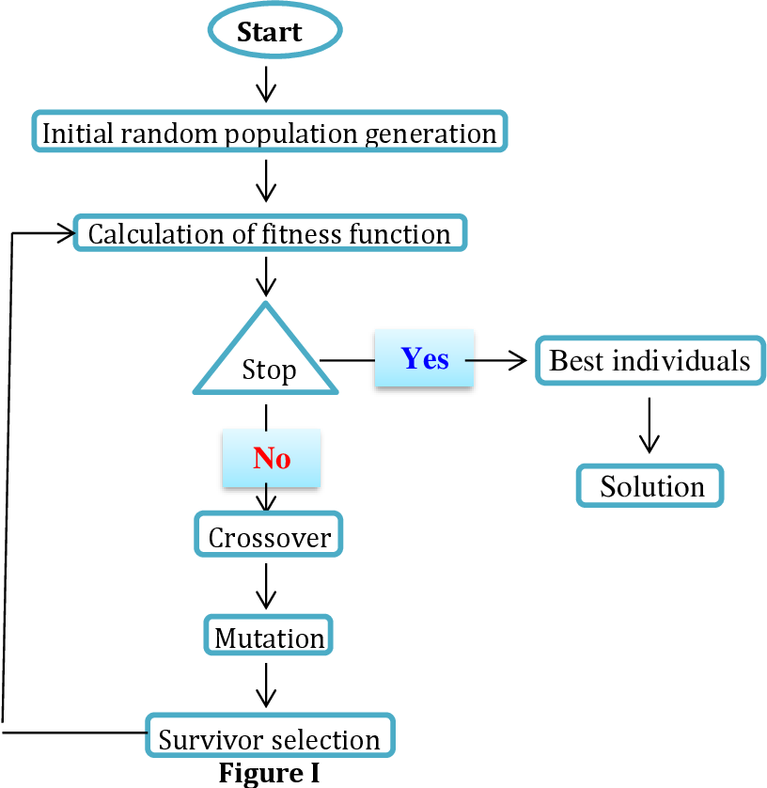

Figure 1 Genetic Algorithm Working

**1.2.1 Initialization**

Initializing a population of potential solutions. In this case, the solutions represent different course schedules.

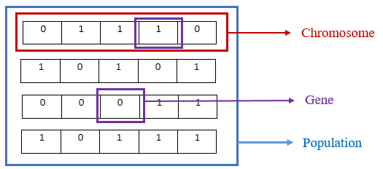

Figure 2 Genetic algorithm initialization

**1.2.2 Fitness Function**

**Fitness Function:** Evaluating the fitness of each solution in the population. The fitness function assesses how well each schedule satisfies certain criteria, such as minimizing conflicts or

maximizing instructors preferences.

**1.2.3 Selection:**

Selecting individuals from the current population to serve as parents for producing offspring. Common selection methods include roulette wheel selection, tournament selection, or rank-based selection.

**1.2.4 Crossover**

Combining genetic material from two parent solutions to produce offspring solutions. This is typically done by selecting a crossover point and exchanging genetic information beyond that point between parents.

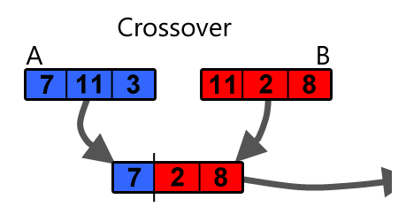

Figure 3 Crossover in Genetic Algorithm

**1.2.5 Mutation**

Introducing random changes in offspring solutions to maintain genetic diversity within the population. Mutation helps prevent premature convergence to suboptimal solutions.

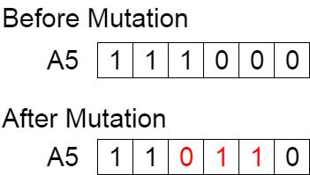

Figure 4 Mutation in genetic algorithm

**1.2.6 Replacement**

Selecting individuals from the current population and the newly generated offspring population to form the next generation. This process may involve elitism, where the best individuals are preserved in each generation.

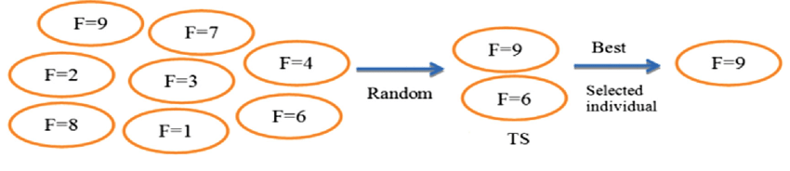

Figure 5 Selection in genetic algorithm

**1.2.7 Termination Condition**

Determining when to stop the algorithm. This could be after a certain number of generations or when a satisfactory solution is found.

* 1. **Motivation**

The motivation behind this thesis stems from the recognition of the significant challenges and inefficiencies inherent in manual course scheduling processes within educational institutions. As students, educators, and administrators alike have experienced firsthand, the manual scheduling of courses and teachers often leads to scheduling conflicts, suboptimal resource allocation, and increased administrative burden.

By automating the course scheduling process, we aim to address these challenges and improve the overall efficiency and effectiveness of educational operations. The motivation for this thesis lies in the potential impact that an automated course scheduling system can have on streamlining operations, reducing administrative overhead, and enhancing the learning experience for students.

Through the development of an automated course scheduler, we seek to provide a solution that not only alleviates the burden of manual scheduling but also introduces optimization techniques to generate schedules that are efficient, conflict-free, and tailored to the specific constraints and requirements of each educational institution.

Furthermore, the motivation for this thesis also lies in the opportunity to contribute to the broader body of knowledge and research in the field of educational scheduling. By exploring and implementing novel methodologies such as genetic algorithms, we aim to advance the state-of-the-art in course scheduling and provide insights and best practices that can benefit educational institutions worldwide.

Ultimately, the motivation for this thesis is rooted in the belief that by harnessing the power of automation and optimization, we can revolutionize the way educational institutions manage their scheduling processes, leading to improved efficiency, enhanced resource utilization, and a better overall learning experience for students.

* 1. **Objective**

The objective of this thesis is to design, develop, and implement an automated course scheduling system for educational institutions. Overall, the objective of this thesis is to provide educational institutions with a robust, efficient, and scalable solution for automating the course scheduling process, thereby improving operational efficiency and enhancing the learning experience for students.

The specific objectives include:

1. Designing a user-friendly interface for inputting course, teacher, and scheduling constraint data.
2. Developing a backend system using the Python Django framework to manage course scheduling logic and algorithms.
3. Implementing a genetic algorithm module to generate optimized schedules based on input data and constraints.
4. Integrating error handling functions to detect and resolve conflicts in the generated schedules.
5. Evaluating the performance and effectiveness of the automated course scheduling system through rigorous testing and analysis.
6. Providing recommendations for further improvements and enhancements to the automated course scheduling system based on the evaluation results.

**Research Objective:**

The research objective of this thesis is to explore and implement novel methodologies, such as genetic algorithms, for automating course scheduling processes in educational institutions. By investigating the effectiveness of these methodologies and their applicability to real-world scheduling challenges, the research aims to advance the understanding of course scheduling optimization techniques and contribute to the body of knowledge in the field.

**Academic Objective:**

The academic objective of this thesis is to demonstrate the feasibility and effectiveness of automated course scheduling systems in improving operational efficiency and resource utilization within educational institutions. By developing a comprehensive understanding of the underlying principles and algorithms involved in course scheduling automation, the academic objective is to provide valuable insights and recommendations for future research and implementation efforts in the field.

**Management Objective:**

The management objective of this thesis is to provide educational institutions with a practical and actionable solution for streamlining course scheduling processes. By implementing an automated course scheduling system, the management objective is to reduce administrative burden, minimize scheduling conflicts, and optimize resource allocation, ultimately leading to improved operational efficiency and enhanced academic outcomes within the institution.

* 1. **Challenges**

**1. Genetic Algorithm Complexity:** One of the primary challenges of this project is the complexity associated with implementing genetic algorithms for course scheduling. Genetic algorithms are known for their computational intensity, especially when applied to optimization problems like course scheduling, which can be likened to a knapsack problem. The process of generating optimal schedules while considering various constraints and preferences adds another layer of complexity to the algorithm.

**2. Data Accessibility:** Obtaining accurate and reliable data for course scheduling poses a significant challenge. Educational institutions are often reluctant to share sensitive scheduling data with third-party applications due to privacy concerns and trust issues. This necessitates the development of strategies to collect and utilize data effectively while maintaining trust and compliance with data protection regulations.

**3. Quota Limitations:** Another challenge is the quota limitations imposed by cloud computing platforms or hosting services for uploading and processing large volumes of data. Since course scheduling involves processing substantial amounts of data, including course offerings, instructor availability, and classroom capacities, the project may encounter difficulties in managing quota arrangements for data uploading and processing, especially if the budget is limited.

**4. Algorithm Optimization:** Optimizing the genetic algorithm to efficiently handle course scheduling constraints and preferences is a significant challenge. Balancing the trade-offs between computational complexity and solution quality requires careful tuning of algorithm parameters and heuristics. Additionally, addressing edge cases and corner scenarios to ensure robustness and reliability of the scheduling algorithm adds to the challenge of algorithm optimization.

**5. User Interface Design:** Designing an intuitive and user-friendly interface for inputting scheduling preferences and viewing generated schedules is another challenge. The interface must accommodate diverse user needs and preferences while maintaining simplicity and clarity. Ensuring seamless integration between the backend scheduling engine and frontend user interface adds complexity to the interface design process.

Overall, overcoming these challenges requires a multidisciplinary approach, combining expertise in algorithm design, data management, user interface design, and project management. By addressing these challenges effectively, the project aims to deliver a reliable, efficient, and user-friendly automated course scheduling system that meets the needs of educational institutions and stakeholders.

* 1. **Structure of Report**

This marks the completion of chapter one of the Automatic Course Scheduler. This chapter highlighted the overall concept of the automatic course scheduler. The introduction section presents an in-depth overview of the concept behind the automated course scheduler. The problem statement identifies the specific challenges addressed by this application and outlines its potential benefits for educational institutions. The motivation section elucidates the driving factors behind the development of the automated course scheduler, providing insight into the inspiration and rationale for its creation.

As we delve deeper into Chapter One, the objectives of the project become apparent. Here, readers will encounter essential details such as research objectives, academic objectives, and management objectives. Additionally, challenges associated with the development and utilization of the automated course scheduler are addressed. Lastly, the structure of the project report is outlined, providing a roadmap for the subsequent chapters.

## Chapter 2: Technology Background

## Chapter 2 will offer a comprehensive literature review encompassing the existing body of research relevant to automated course scheduling and the underlying technologies utilized in the project.

## Chapter 3: Requirements & Methodology

## Chapter 3 will provide an in-depth discussion of the fundamental system models, alongside the presentation of both functional and nonfunctional requirements essential for our project.

## Chapter 4: Project Plan & Initial Design

## This chapter will encompass detailed project designs aimed at facilitating developers' understanding of the project's implementation and establishing a clear pathway for system development.

## Chapter 5: Project Design & Development

## Chapter 5 stands as a pivotal chapter, outlining the actual design and implementation phases of the automated course scheduler. It delves into the various stages of design and development.

## Chapter 6: Testing

## In this chapter, we will construct test cases, including front-end (design testing) and back-end (source code) testing. Additionally, we will employ testing tools to conduct comprehensive testing and integrate the results into the report.

## Chapter 7: Conclusion

## Chapter 7 serves as the culmination of our work, where we will present our findings, including facts, figures, tables, and graphs.

## We will discuss the encountered limitations and challenges and outline future work to be undertaken.

# CHAPTER – 2

1. **Technology Background**

Chapter 2 of this thesis provides a comprehensive exploration of the technological landscape underpinning the automated course scheduling project. Drawing upon extensive literature review and research, this chapter offers insights into the various methodologies, algorithms, and technologies utilized in the development of the automated course scheduling system.

The technology background begins by examining the foundational concepts of course scheduling in educational institutions. This includes an overview of traditional manual scheduling processes, highlighting the inherent challenges and inefficiencies that necessitate the adoption of automated solutions.

Furthermore, the chapter delves into the theoretical underpinnings of genetic algorithms, a key methodology employed in the automated course scheduling project. Genetic algorithms simulate the process of natural selection to iteratively generate optimal solutions, making them particularly well-suited for complex optimization problems such as course scheduling.

* 1. **Background of the technology:**

The technology utilized in this project encompasses a modern stack of tools and frameworks tailored to address the complexities of automated course scheduling. Leveraging Python Django for backend development, HTML/CSS for frontend design, and genetic algorithms for optimization, this project integrates cutting-edge technologies to streamline the course scheduling process. These technologies offer robustness, scalability, and flexibility, allowing for efficient management of course assignments, instructor allocations, and scheduling constraints. Additionally, the adoption of cloud computing and database management systems ensures seamless data handling and accessibility, while user-centric design principles guarantee an intuitive and engaging user experience. Overall, the background of the technology used in this project reflects a commitment to innovation and efficiency in educational scheduling solutions.

## Visual Studio

## Visual Studio was chosen for this project due to its robust integrated development environment (IDE) and comprehensive toolset tailored for web development. With features such as IntelliSense for code completion, debugging capabilities, and seamless integration with version control systems like Git, Visual Studio enhances productivity and facilitates collaborative development. Moreover, its support for various programming languages and frameworks, including Python Django and HTML/CSS, aligns perfectly with the technological requirements of the automated course scheduling project. Overall, Visual Studio offers a seamless and efficient development experience, making it the preferred choice for this endeavor.

## Python

## Python was selected as the primary programming language for this project due to its versatility, readability, and extensive ecosystem of libraries and frameworks. As a high-level language, Python allows for rapid development and easy integration of complex functionalities, making it well-suited for building the backend logic of the automated course scheduling system. Additionally, Python's support for object-oriented and functional programming paradigms enables the creation of modular and scalable code, facilitating maintenance and future enhancements. Furthermore, Python's popularity within the data science and artificial intelligence communities aligns with the use of genetic algorithms for optimizing course schedules. Overall, Python's combination of simplicity and power makes it an ideal choice for implementing the core functionality of the automated course scheduling project.Top of Form

## Html / CSS

## HTML and CSS were chosen for frontend development due to their simplicity, widespread support, and beginner-friendly nature. They allow for rapid prototyping, easy customization, and maintainability, essential for creating an intuitive and visually appealing user interface for the automated course scheduling system.

* 1. **Literature Review**

## The scheduling of courses and teachers in educational institutions presents a multifaceted challenge that has garnered extensive attention in scholarly literature. The subsequent literature review offers a comprehensive examination of pertinent concepts, methodologies, and approaches pertaining to automated course scheduling. Traditional scheduling methods, often reliant on manual processes or basic software tools, are noted for their time-consuming nature, susceptibility to errors, and limited optimization capabilities, resulting in inefficiencies and suboptimal outcomes.

## In response, optimization techniques such as genetic algorithms, simulated annealing, and constraint programming have emerged as viable solutions to automate the scheduling process. Among these, genetic algorithms stand out for their ability to generate high-quality schedules by emulating natural selection and evolutionary principles to iteratively refine solutions. Genetic algorithm-based scheduling approaches, frequently employed across various scheduling domains, including education, involve encoding solutions as chromosomes, applying genetic operators like selection, crossover, and mutation, and evaluating solutions based on fitness functions capturing scheduling objectives and constraints.

## Illustrative case studies and real-world applications underscore the practical efficacy of automated course scheduling systems in diverse educational contexts, shedding light on the myriad challenges, requirements, and solutions encountered. Ultimately, the literature underscores the pivotal role of automated course scheduling in streamlining operations, alleviating administrative burdens, and elevating academic outcomes within educational institutions. Leveraging optimization methodologies like genetic algorithms, researchers and practitioners can forge effective scheduling systems adept at addressing the intricacies and constraints inherent in educational scheduling environments.

# CHAPTER – 3

* 1. **Introduction:**

In this chapter we will discuss about how much work is done on the development of our project according to the project plan. This chapter will cover the in-detail process and objective of the project. As our app is built on windows that are being reused within the system itself the developers had to take a systematic approach for the app to work smoothly. Our project plan is strategically planned with the Gantt chart and other organizational tools. Each activity has specific time period allotted according to the complexity of the task, which is why the days in work may vary.

We will also discuss in detail about the Functional, Non-Functional and Hardware requirements of our project. The functional requirement are taken in to full consideration as they are the necessary part in order to get the basic requirement by the project such as, camera detection and learning objective, while on the other hand, the non-functional requirement such as, settings and feedback are also thoroughly planned.

* 1. **Project Plan:**

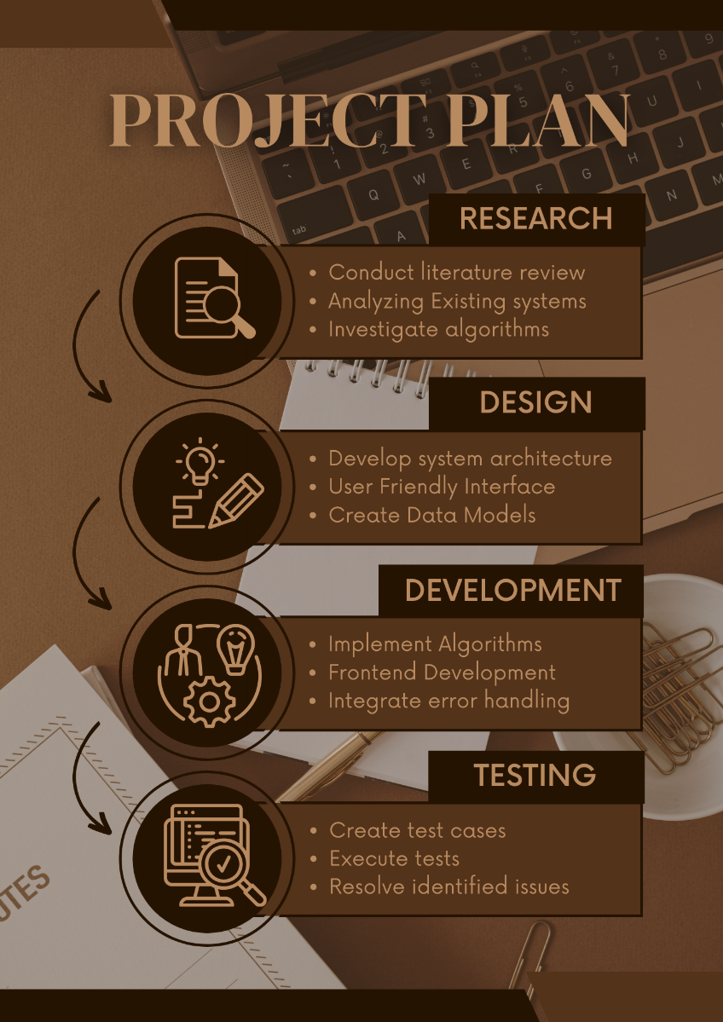

Figure 6 Project plan

* 1. **Functional Requirements:**
     + 1. **Input Information:** The system must allow input of course, teacher, and classroom details.
       2. **Constraints:** Users should input constraints and preferences for each course and instructor.
       3. **Schedule Generation:** The system should generate schedules for courses and instructors.
       4. **Classroom Scheduling**: Ability to generate schedules for each classroom.
       5. **Avoid Conflicts:** Ensure no instructor has more than one class simultaneously.
       6. **Instructor Preferences:** Allow instructors to specify preferred courses.
       7. **Multiple Sessions:** Each course can have multiple sessions, each with an assigned instructor.
       8. **Export Functionality:** Ability to export schedules to formats like PDF or CSV.
       9. **Conflict Recognition:** Recognize conflicts based on the error handling aspect.
       10. **Course Listing:** Display available courses, times, and locations on the interface.
       11. **Optimization:** Consider classroom availability for an optimized schedule.
       12. **Instructor Preferences:** Accommodate instructor preferences and availability during schedule generation.

* 1. **Non-Functional Requirements:**
     + 1. **Performance:** The scheduling algorithm must efficiently handle large data sets.
       2. **Scalability**: The system should scale to accommodate a large volume of course, instructor, and classroom data.
       3. **Security**: Ensure data and user information security.
       4. **Reliability**: The system must be reliable and available at all times.
       5. **Portability**: Run on various platforms and operating systems.
       6. **Support**: Provide dedicated support for technical assistance.

Interoperability: Ability to integrate with existing institution systems or software.

* 1. **Hardware Requirements:**

The hardware requirements for the automatic course scheduling system are outlined below:

1. **Server or Hosting Platform:**

The system requires a server or hosting platform to deploy the backend components, such as the database and scheduling algorithms.

Minimum specifications include sufficient processing power, memory (RAM), and storage to accommodate database operations and algorithm computations.

1. **Network Connectivity:**

Reliable internet connectivity is essential for accessing the system remotely and facilitating communication between users and the server.

High-speed internet connectivity is recommended to ensure efficient data transfer and system responsiveness.

1. **Client Devices:**

Users will access the system through client devices such as desktop computers, laptops, tablets, or smartphones.

Client devices should meet basic requirements for web browsing and accessing web applications.

Compatibility with modern web browsers (e.g., Google Chrome, Mozilla Firefox, Safari) is necessary for optimal performance and user experience.

1. **Storage Devices (Optional):**

Additional storage devices may be required for data backup and archival purposes.

Cloud storage solutions can be utilized for storing backups and ensuring data redundancy.

1. **Peripheral Devices (Optional):**

Peripheral devices such as printers or external monitors may be used for printing schedules or displaying system information, respectively.

1. **Backup and Redundancy Systems:**

Implementing backup and redundancy systems is recommended to ensure data integrity and system availability.

1. **Scalability Considerations:**

The hardware infrastructure should be scalable to accommodate potential increases in system usage, data volume, and user concurrency.

1. **Security Measures:**

Hardware-based security measures, such as firewalls, intrusion detection systems, and encryption protocols, should be implemented to safeguard system assets and protect against unauthorized access or data breaches.

* 1. **Summary:**

Chapter 3 outlines the functional and non-functional requirements guiding the development of the automatic course scheduling system. It highlights essential capabilities such as inputting course information, handling conflicts, and providing a user-friendly interface. The methodology section discusses Agile principles and iterative development cycles, emphasizing collaboration and adaptability. Overall, this chapter provides a framework for the systematic development of the system, ensuring its reliability and effectiveness in addressing scheduling challenges in educational institutions.

# CHAPTER – 4

* 1. **Introduction:**

Chapter 4 delves into the design and specification of the automatic course scheduling system, detailing the data models.

The chapter describes the data models used in the system to represent course information, teacher details, classroom availability, and scheduling constraints. Entity-relationship diagrams (ERDs) or similar visual representations are provided to illustrate the relationships between different data entities and their attributes. The design rationale behind each data model is explained, highlighting considerations such as data integrity, normalization, and efficiency.

* 1. **Entity Relationship Diagram:**

The Entity Relationship diagram has been displayed below:

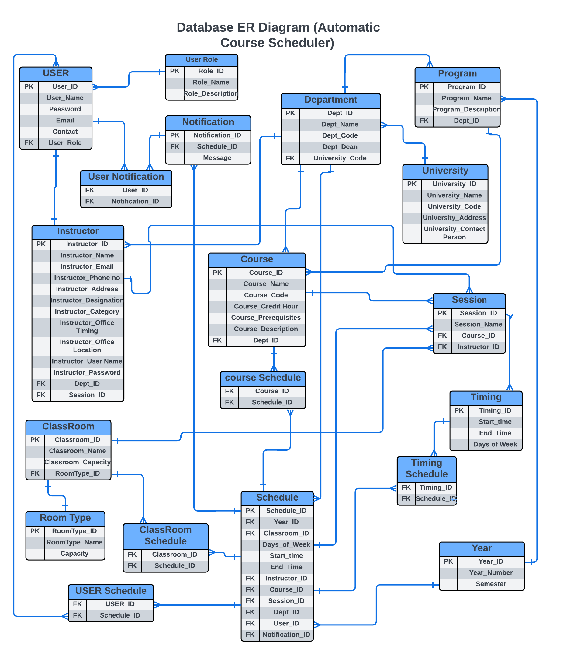

* 1. **Summary**

Chapter 4 focuses on the design and specification of the automatic course scheduling system. The chapter primarily presents the Entity-Relationship Diagram (ERD) depicting the relationships between various data entities such as courses, teachers, classrooms, and scheduling constraints. By showcasing the ERD, the chapter provides a visual representation of the underlying data structure and relationships within the system. This design element serves as a foundational framework for the subsequent phases of system development and implementation. The ERD's simplicity and clarity facilitate understanding and collaboration among project stakeholders, laying the groundwork for further refinement and enhancement of the automatic course scheduling system.

# CHAPTER – 5

# 5.1 Introduction

# We've integrated several external libraries into our project to enhance its functionality. Additionally, we've included screenshots of the complete system to provide a better visual understanding of how everything works together. These screenshots offer a comprehensive view of our project's user interface and design, allowing for a clearer appreciation of its overall structure and functionality.

# 5.2 Screenshots

# Home page:

# 

# Login Page:

# 

# SignUP page:

# 

# Admin Dashboard:

# 

# Add Instructor Page:

# 

# List of instructors:

# 

# Add Room page:

# 

# List of Classrooms:

# 

# Add Meeting timing page:

# 

# List of Meeting Timings:

# 

# Add Courses page:

# 

# List of added courses:

# 

# Add Department page:

# 

# View list of department :

# 

# Add Sections page:

# 

# View list of Sections:

# 

# Generate TimeTable Page:

# 

# : View Generated Schedule;

# 

# : Upload Schedule Pdf:

# 

# : Upload CSV for conflicts Resolution:

# 

# View Conflicts

# 

# View Schedule

# 

# Change Password

# 

# : Logout window:

# 

# 5.3 Summary

In this chapter, we showcase screenshots of our complete system, offering a comprehensive visual overview of its user interface and functionality. These images provide insight into how our project looks and operates, allowing for a better understanding of its design and features. By including these screenshots, we aim to offer readers a clearer perspective on the overall structure and layout of our system.

# CHAPTER – 6

# Introduction:

In Chapter 6, the focus shifts towards the crucial testing phase of the automatic course scheduling software. This phase plays a pivotal role in ensuring that the developed system meets the desired standards of functionality, performance, and reliability. The chapter outlines a comprehensive set of test cases meticulously designed to evaluate different aspects of the software's behavior.

The testing process encompasses various dimensions, including input validation, schedule generation, conflict resolution, export functionality, and user interface usability. Each test case is meticulously crafted to assess specific functionalities and features of the software, ensuring that it operates flawlessly under different scenarios and conditions.

By systematically executing these test cases, the chapter aims to validate the accuracy and effectiveness of the automatic course scheduling system. Through rigorous testing, any potential issues, bugs, or inconsistencies can be identified and addressed promptly, thus enhancing the overall quality and robustness of the software.

# Test Cases:

**Test Case 1:**

|  |  |  |  |
| --- | --- | --- | --- |
| **Requirement Reference** | 1 | **Project Name** | Automatic Course Scheduler |
| **Test Case Id** | 1.1 | **Test Type** | Functionality |
| **Test Case Description** | 1. To test that login button works. 2. To test that signup button works. | | |
| **Test Steps** | 1. Click on login button. 2. Click on signup button. | | |
| **Expected Result** | 1. Click on login redirect to login page. 2. Click on signup redirect to sign up. | | |
| **Actual Result** | 1. Click on login redirect to login page. 2. Click on signup redirect to sign up. | | |
| **Pass/Fail** | Pass | | |
| **Date Prepared** | March 15, 2024 | | |
| **Date Run** | March 22, 2024 | | |
| **Prepared By** | Abdul Majid | | |
| **Tested By** | Taha Ammar Mir and Muhammad Ghulam Hamza | | |

**TEST CASE 2:**

|  |  |  |  |
| --- | --- | --- | --- |
| **Requirement Reference** | 1 | **Project Name** | Automatic Course Scheduler |
| **Test Case Id** | 1.2 | **Test Type** | Functionality |
| **Test Case Description** | 1. To test that the Register new account text on Login screen. 2. To test that Login here text on Register screen. | | |
| **Test Steps** | 1. Click on text login here 2. Click on text register here | | |
| **Expected Result** | 1. Open registration screen 2. Open Login screen | | |
| **Actual Result** | 1. Open registration screen. 2. Open login screen. | | |
| **Pass/Fail** | Pass | | |
| **Date Prepared** | March 15, 2024 | | |
| **Date Run** | March 22, 2024 | | |
| **Prepared By** | Abdul Majid | | |
| **Tested By** | Taha Ammar Mir and Muhammad Ghulam Hamza | | |

**TEST CASE 3:**

|  |  |  |  |
| --- | --- | --- | --- |
| **Requirement Reference** | 1 | **Project Name** | Automatic Course Scheduler |
| **Test Case Id** | 1.3 | **Test Type** | Functionality |
| **Test Case Description** | To check that text fields in Register Screen must be mandatory to register a unique use. | | |
| **Test Steps** | Click on Create my Account. | | |
| **Expected Result** | Please fill out the required fields. | | |
| **Actual Result** | Please fill out the required fields. | | |
| **Pass/Fail** | Pass | | |
| **Date Prepared** | March 15, 2024 | | |
| **Date Run** | March 22, 2024 | | |
| **Prepared By** | Abdul Majid | | |
| **Tested By** | Taha Ammar Mir and Muhammad Ghulam Hamza | | |

**TEST CASE 4:**

|  |  |  |  |
| --- | --- | --- | --- |
| **Requirement Reference** | 1 | **Project Name** | Automatic Course Scheduler |
| **Test Case Id** | 1.4 | **Test Type** | Functionality |
| **Test Case Description** | To check password and match password function works. | | |
| **Test Steps** | Click on Create my Account. | | |
| **Expected Result** | Password didn’t match. | | |
| **Actual Result** | Password didn’t match. | | |
| **Pass/Fail** | Pass | | |
| **Date Prepared** | March 15, 2024 | | |
| **Date Run** | March 22, 2024 | | |
| **Prepared By** | Abdul Majid | | |
| **Tested By** | Taha Ammar Mir and Muhammad Ghulam Hamza | | |

**TEST CASE 5:**

|  |  |  |  |
| --- | --- | --- | --- |
| **Requirement Reference** | 1 | **Project Name** | Automatic Course Scheduler |
| **Test Case Id** | 1.5 | **Test Type** | Functionality |
| **Test Case Description** | To check create my account button creates the account of user | | |
| **Test Steps** | Click on Create my Account. | | |
| **Expected Result** | User account get created. | | |
| **Actual Result** | User account get created. | | |
| **Pass/Fail** | Pass | | |
| **Date Prepared** | March 15, 2024 | | |
| **Date Run** | March 22, 2024 | | |
| **Prepared By** | Abdul Majid | | |
| **Tested By** | Taha Ammar Mir and Muhammad Ghulam Hamza | | |

**TEST CASE 6:**

|  |  |  |  |
| --- | --- | --- | --- |
| **Requirement Reference** | 1 | **Project Name** | Automatic Course Scheduler |
| **Test Case Id** | 1.6 | **Test Type** | Functionality |
| **Test Case Description** | To check that text fields in Login Screen must be mandatory to login into course generation panel. | | |
| **Test Steps** | Click on Login Button. | | |
| **Expected Result** | User login into in the schedule generation page. | | |
| **Actual Result** | User login into in the schedule generation page. | | |
| **Pass/Fail** | Pass | | |
| **Date Prepared** | March 15, 2024 | | |
| **Date Run** | March 22, 2024 | | |
| **Prepared By** | Abdul Majid | | |
| **Tested By** | Taha Ammar Mir and Muhammad Ghulam Hamza | | |

**TEST CASE 7:**

|  |  |  |  |
| --- | --- | --- | --- |
| **Requirement Reference** | 1 | **Project Name** | Automatic Course Scheduler |
| **Test Case Id** | 1.7 | **Test Type** | Functionality |
| **Test Case Description** | To check that wrong credential must not login into system. | | |
| **Test Steps** | Click on Login Button. | | |
| **Expected Result** | Enter correct username and password. | | |
| **Actual Result** | Enter correct username and password. | | |
| **Pass/Fail** | Pass | | |
| **Date Prepared** | March 15, 2024 | | |
| **Date Run** | March 22, 2024 | | |
| **Prepared By** | Abdul Majid | | |
| **Tested By** | Taha Ammar Mir and Muhammad Ghulam Hamza | | |

**TEST CASE 8:**

|  |  |  |  |
| --- | --- | --- | --- |
| **Requirement Reference** | 1 | **Project Name** | Automatic Course Scheduler |
| **Test Case Id** | 1.8 | **Test Type** | Functionality |
| **Test Case Description** | To check the Add Instructors functions works properly and instructors are added into database. | | |
| **Test Steps** | Click on Add instructor. | | |
| **Expected Result** | Instructor is added into database. | | |
| **Actual Result** | Instructor is added into database. | | |
| **Pass/Fail** | Pass | | |
| **Date Prepared** | March 15, 2024 | | |
| **Date Run** | March 22, 2024 | | |
| **Prepared By** | Abdul Majid | | |
| **Tested By** | Taha Ammar Mir and Muhammad Ghulam Hamza | | |

**TEST CASE 9:**

|  |  |  |  |
| --- | --- | --- | --- |
| **Requirement Reference** | 1 | **Project Name** | Automatic Course Scheduler |
| **Test Case Id** | 1.9 | **Test Type** | Functionality |
| **Test Case Description** | To check the Add Instructors text input fields must be mandatory to add instructor. | | |
| **Test Steps** | Click on Add instructor. | | |
| **Expected Result** | Please fill the require field. | | |
| **Actual Result** | Please fill the require field. | | |
| **Pass/Fail** | Pass | | |
| **Date Prepared** | March 15, 2024 | | |
| **Date Run** | March 22, 2024 | | |
| **Prepared By** | Abdul Majid | | |
| **Tested By** | Taha Ammar Mir and Muhammad Ghulam Hamza | | |

**TEST CASE 10:**

|  |  |  |  |
| --- | --- | --- | --- |
| **Requirement Reference** | 1 | **Project Name** | Automatic Course Scheduler |
| **Test Case Id** | 1.10 | **Test Type** | Functionality |
| **Test Case Description** | To check the view instructor button works and it show the already added instructors. | | |
| **Test Steps** | Click on View/Edit instructor. | | |
| **Expected Result** | Display all the added instructors. | | |
| **Actual Result** | Display all the added instructors. | | |
| **Pass/Fail** | Pass | | |
| **Date Prepared** | March 15, 2024 | | |
| **Date Run** | March 22, 2024 | | |
| **Prepared By** | Abdul Majid | | |
| **Tested By** | Taha Ammar Mir and Muhammad Ghulam Hamza | | |

**TEST CASE 11:**

|  |  |  |  |
| --- | --- | --- | --- |
| **Requirement Reference** | 1 | **Project Name** | Automatic Course Scheduler |
| **Test Case Id** | 1.11 | **Test Type** | Functionality |
| **Test Case Description** | To check that added instructors can be deleted from the list of instructors.. | | |
| **Test Steps** | Click on delete button. | | |
| **Expected Result** | Instructor is deleted from the database. | | |
| **Actual Result** | Instructor is deleted from the database. | | |
| **Pass/Fail** | Pass | | |
| **Date Prepared** | March 15, 2024 | | |
| **Date Run** | March 22, 2024 | | |
| **Prepared By** | Abdul Majid | | |
| **Tested By** | Taha Ammar Mir and Muhammad Ghulam Hamza | | |

**TEST CASE 11:**

|  |  |  |  |
| --- | --- | --- | --- |
| **Requirement Reference** | 1 | **Project Name** | Automatic Course Scheduler |
| **Test Case Id** | 1.11 | **Test Type** | Functionality |
| **Test Case Description** | To check that back button which redirect to add instructor panel from view instructor panel works. | | |
| **Test Steps** | Click on Back to add instructors. | | |
| **Expected Result** | Redirect to add instructor page. | | |
| **Actual Result** | Redirect to add instructor page. | | |
| **Pass/Fail** | Pass | | |
| **Date Prepared** | March 15, 2024 | | |
| **Date Run** | March 22, 2024 | | |
| **Prepared By** | Abdul Majid | | |
| **Tested By** | Taha Ammar Mir and Muhammad Ghulam Hamza | | |

**TEST CASE 12:**

|  |  |  |  |
| --- | --- | --- | --- |
| **Requirement Reference** | 1 | **Project Name** | Automatic Course Scheduler |
| **Test Case Id** | 1.12 | **Test Type** | Functionality |
| **Test Case Description** | To check the Add Room functions works properly and Rooms are added into database. | | |
| **Test Steps** | Click on Add Room. | | |
| **Expected Result** | Room is added into database. | | |
| **Actual Result** | Room is added into database. | | |
| **Pass/Fail** | Pass | | |
| **Date Prepared** | March 15, 2024 | | |
| **Date Run** | March 22, 2024 | | |
| **Prepared By** | Abdul Majid | | |
| **Tested By** | Taha Ammar Mir and Muhammad Ghulam Hamza | | |

**TEST CASE 13:**

|  |  |  |  |
| --- | --- | --- | --- |
| **Requirement Reference** | 1 | **Project Name** | Automatic Course Scheduler |
| **Test Case Id** | 1.13 | **Test Type** | Functionality |
| **Test Case Description** | To check the Add Room text input fields must be mandatory to add Room. | | |
| **Test Steps** | Click on Add Room. | | |
| **Expected Result** | Please fill the require field. | | |
| **Actual Result** | Please fill the require field. | | |
| **Pass/Fail** | Pass | | |
| **Date Prepared** | March 15, 2024 | | |
| **Date Run** | March 22, 2024 | | |
| **Prepared By** | Abdul Majid | | |
| **Tested By** | Taha Ammar Mir and Muhammad Ghulam Hamza | | |

**TEST CASE 14:**

|  |  |  |  |
| --- | --- | --- | --- |
| **Requirement Reference** | 1 | **Project Name** | Automatic Course Scheduler |
| **Test Case Id** | 1.14 | **Test Type** | Functionality |
| **Test Case Description** | To check the view room button works and it show the already added rooms. | | |
| **Test Steps** | Click on View/Edit room. | | |
| **Expected Result** | Display all the added room. | | |
| **Actual Result** | Display all the added room. | | |
| **Pass/Fail** | Pass | | |
| **Date Prepared** | March 15, 2024 | | |
| **Date Run** | March 22, 2024 | | |
| **Prepared By** | Abdul Majid | | |
| **Tested By** | Taha Ammar Mir and Muhammad Ghulam Hamza | | |

**TEST CASE 15:**

|  |  |  |  |
| --- | --- | --- | --- |
| **Requirement Reference** | 1 | **Project Name** | Automatic Course Scheduler |
| **Test Case Id** | 1.15 | **Test Type** | Functionality |
| **Test Case Description** | To check that added room can be deleted from the list of room.. | | |
| **Test Steps** | Click on delete room button. | | |
| **Expected Result** | Room is deleted from the database. | | |
| **Actual Result** | Room is deleted from the database. | | |
| **Pass/Fail** | Pass | | |
| **Date Prepared** | March 15, 2024 | | |
| **Date Run** | March 22, 2024 | | |
| **Prepared By** | Abdul Majid | | |
| **Tested By** | Taha Ammar Mir and Muhammad Ghulam Hamza | | |

**TEST CASE 16:**

|  |  |  |  |
| --- | --- | --- | --- |
| **Requirement Reference** | 1 | **Project Name** | Automatic Course Scheduler |
| **Test Case Id** | 1.16 | **Test Type** | Functionality |
| **Test Case Description** | To check that back button which redirect to add room panel from view room panel works. | | |
| **Test Steps** | Click on Back to add room. | | |
| **Expected Result** | Redirect to add room page. | | |
| **Actual Result** | Redirect to add room page. | | |
| **Pass/Fail** | Pass | | |
| **Date Prepared** | March 15, 2024 | | |
| **Date Run** | March 22, 2024 | | |
| **Prepared By** | Abdul Majid | | |
| **Tested By** | Taha Ammar Mir and Muhammad Ghulam Hamza | | |

**TEST CASE 17:**

|  |  |  |  |
| --- | --- | --- | --- |
| **Requirement Reference** | 1 | **Project Name** | Automatic Course Scheduler |
| **Test Case Id** | 1.17 | **Test Type** | Functionality |
| **Test Case Description** | 1. To check the Add Meeting time functions works properly and meeting time are added into database. 2. To check all the required fields must be filled. 3. To check view meeting time button works and show already added meeting times. 4. To check meeting times can be deleted from the view panel. 5. To check that back button which redirect to add meeting panel from view meeting time panel works. | | |
| **Test Steps** | 1. Click on Add meeting time. 2. Click on Add meeting time. 3. Click on View meeting time. 4. Click on delete meeting time 5. Click on back to add meeting time button. | | |
| **Expected Result** | 1. Meeting time is added into database. 2. Please fill the require field. 3. Display all the added Meeting times. 4. Meeting time is deleted from the database. 5. Redirect to add meeting time page. | | |
| **Actual Result** | 1. Meeting time is added into database. 2. Please fill the require field. 3. Display all the added Meeting times. 4. Meeting time is deleted from the database. 5. Redirect to add meeting time page. | | |
| **Pass/Fail** | Pass | | |
| **Date Prepared** | March 15, 2024 | | |
| **Date Run** | March 22, 2024 | | |
| **Prepared By** | Abdul Majid | | |
| **Tested By** | Taha Ammar Mir and Muhammad Ghulam Hamza | | |

**TEST CASE 18:**

|  |  |  |  |
| --- | --- | --- | --- |
| **Requirement Reference** | 1 | **Project Name** | Automatic Course Scheduler |
| **Test Case Id** | 1.18 | **Test Type** | Functionality |
| **Test Case Description** | 1. To check the Add Courses functions works properly and Courses are added into database. 2. To check all the required fields must be filled. 3. To check view Courses button works and show already added Courses. 4. To check instructor selection box select the instructors. 5. To check search instructor function searching the instructor. 6. To check Courses can be deleted from the view panel. 7. To check that back button which redirect to add Courses from view Course panel works. | | |
| **Test Steps** | 1. Click on Add Course. 2. Click on Add course. 3. Click on View courses. 4. Click on tick box. 5. Search inn search box. 6. Click on delete Course. 7. Click on back to add Course button. | | |
| **Expected Result** | 1. Courses is added into database. 2. Please fill the require field. 3. Display all the added Courses. 4. Show tick in the selected instructor box. 5. Display name of instructor who is being searched. 6. Course is deleted from the database. 7. Redirect to add courses page. | | |
| **Actual Result** | 1. Courses is added into database. 2. Please fill the require field. 3. Display all the added Courses. 4. Show tick in the selected instructor box. 5. Display name of instructor who is being searched. 6. Course is deleted from the database. 7. Redirect to add courses page. | | |
| **Pass/Fail** | Pass | | |
| **Date Prepared** | March 15, 2024 | | |
| **Date Run** | March 22, 2024 | | |
| **Prepared By** | Abdul Majid | | |
| **Tested By** | Taha Ammar Mir and Muhammad Ghulam Hamza | | |

**TEST CASE 19:**

|  |  |  |  |
| --- | --- | --- | --- |
| **Requirement Reference** | 1 | **Project Name** | Automatic Course Scheduler |
| **Test Case Id** | 1.19 | **Test Type** | Functionality |
| **Test Case Description** | 1. To check the Add Department functions works properly and Departments are added into database. 2. To check all the required fields must be filled. 3. To check view Department button works and show already added Departments. 4. To check Department corresponding courses are selected to add in department. 5. To check Department can be deleted from the view panel. 6. To check that back button which redirect to add department from view department panel works. | | |
| **Test Steps** | 1. Click on Add Department. 2. Click on Add Department. 3. Click on View department. 4. Select multiple courses. 5. Click on delete department. 6. Click on back to add department button. | | |
| **Expected Result** | 1. Department is added into database. 2. Please fill the require field. 3. Display all the added Departments. 4. Show Selection on the selected Courses box. 5. Department is deleted from the database. 6. Redirect to add Departments page. | | |
| **Actual Result** | 1. Department is added into database. 2. Please fill the require field. 3. Display all the added Departments. 4. Show Selection on the selected Courses box. 5. Department is deleted from the database. 6. Redirect to add Departments page. | | |
| **Pass/Fail** | Pass | | |
| **Date Prepared** | March 15, 2024 | | |
| **Date Run** | March 22, 2024 | | |
| **Prepared By** | Abdul Majid | | |
| **Tested By** | Taha Ammar Mir and Muhammad Ghulam Hamza | | |

**TEST CASE 20:**

|  |  |  |  |
| --- | --- | --- | --- |
| **Requirement Reference** | 1 | **Project Name** | Automatic Course Scheduler |
| **Test Case Id** | 1.20 | **Test Type** | Functionality |
| **Test Case Description** | 1. To check the Add Section functions works properly and Sections are added into database. 2. To check all the required fields must be filled. 3. To check view Sections button works and show already added Sections. 4. To check corresponding department drop down menu show the added departments. 5. To check Sections can be deleted from the view panel. 6. To check that back button which redirect to add sections from view sections panel works. | | |
| **Test Steps** | 1. Click on Add Section. 2. Click on Add Section. 3. Click on View Section. 4. Click on Corresponding Department. 5. Click on delete sections. 6. Click on back to add section button. | | |
| **Expected Result** | 1. Section is added into database. 2. Please fill the require field. 3. Display all the added Sections. 4. Show Corresponding Department in menu. 5. Section is deleted from the database. 6. Redirect to add Section page. | | |
| **Actual Result** | 1. Section is added into database. 2. Please fill the require field. 3. Display all the added Sections. 4. Show Corresponding Department in menu. 5. Section is deleted from the database. 6. Redirect to add Section page. | | |
| **Pass/Fail** | Pass | | |
| **Date Prepared** | March 15, 2024 | | |
| **Date Run** | March 22, 2024 | | |
| **Prepared By** | Abdul Majid | | |
| **Tested By** | Taha Ammar Mir and Muhammad Ghulam Hamza | | |

**TEST CASE 21:**

|  |  |  |  |
| --- | --- | --- | --- |
| **Requirement Reference** | 1 | **Project Name** | Automatic Course Scheduler |
| **Test Case Id** | 1.21 | **Test Type** | Functionality |
| **Test Case Description** | To check generate timetable button generates the timetable and display it after the generation. | | |
| **Test Steps** | Click on Generate Timetable. | | |
| **Expected Result** | The generated timetable is shown after the generation | | |
| **Actual Result** | The generated timetable is shown after the generation | | |
| **Pass/Fail** | Pass | | |
| **Date Prepared** | March 15, 2024 | | |
| **Date Run** | March 22, 2024 | | |
| **Prepared By** | Abdul Majid | | |
| **Tested By** | Taha Ammar Mir and Muhammad Ghulam Hamza | | |

**TEST CASE 22:**

|  |  |  |  |
| --- | --- | --- | --- |
| **Requirement Reference** | 1 | **Project Name** | Automatic Course Scheduler |
| **Test Case Id** | 1.22 | **Test Type** | Functionality |
| **Test Case Description** | To check generate timetable button Show the loading bar after the click event perform on it. | | |
| **Test Steps** | Click on Generate Timetable. | | |
| **Expected Result** | The loading bar display before the generated timetable shows. | | |
| **Actual Result** | In title bar loading icon is shown but not on web page. | | |
| **Pass/Fail** | Fail | | |
| **Date Prepared** | March 15, 2024 | | |
| **Date Run** | March 22, 2024 | | |
| **Prepared By** | Abdul Majid | | |
| **Tested By** | Taha Ammar Mir and Muhammad Ghulam Hamza | | |

**TEST CASE 23:**

|  |  |  |  |
| --- | --- | --- | --- |
| **Requirement Reference** | 1 | **Project Name** | Automatic Course Scheduler |
| **Test Case Id** | 1.23 | **Test Type** | Functionality |
| **Test Case Description** | To download the generated table in pdf and in csv format by clicking on download button. | | |
| **Test Steps** | 1. Click on Download as PDF. 2. Click on download as CSV. | | |
| **Expected Result** | 1. The PDF file is downloaded. 2. The CSV file is downloaded. | | |
| **Actual Result** | 1. The PDF file is downloaded. 2. The CSV file is downloaded. | | |
| **Pass/Fail** | PASS | | |
| **Date Prepared** | March 15, 2024 | | |
| **Date Run** | March 22, 2024 | | |
| **Prepared By** | Abdul Majid | | |
| **Tested By** | Taha Ammar Mir and Muhammad Ghulam Hamza | | |

**TEST CASE 24:**

|  |  |  |  |
| --- | --- | --- | --- |
| **Requirement Reference** | 1 | **Project Name** | Automatic Course Scheduler |
| **Test Case Id** | 1.24 | **Test Type** | Functionality |
| **Test Case Description** | To check that pdf file is can be uploaded into database through upload pdf. | | |
| **Test Steps** | 1. Click on choose file 2. Click on upload button. | | |
| **Expected Result** | 1. Open windows explorer to select the file. 2. The file save in database and display below. | | |
| **Actual Result** | 1. Open windows explorer to select the file. 2. The file save in database and display below. | | |
| **Pass/Fail** | PASS | | |
| **Date Prepared** | March 15, 2024 | | |
| **Date Run** | March 22, 2024 | | |
| **Prepared By** | Abdul Majid | | |
| **Tested By** | Taha Ammar Mir and Muhammad Ghulam Hamza | | |

**TEST CASE 25:**

|  |  |  |  |
| --- | --- | --- | --- |
| **Requirement Reference** | 1 | **Project Name** | Automatic Course Scheduler |
| **Test Case Id** | 1.25 | **Test Type** | Functionality |
| **Test Case Description** | To check that CSV file is uploading to check the schedule constrains. | | |
| **Test Steps** | 1. Click on choose file 2. Click on upload button. | | |
| **Expected Result** | 1. Open windows explorer to select the file. 2. The file save in database and display schedule conflicts. | | |
| **Actual Result** | 1. Open windows explorer to select the file. 2. The file save in database and display schedule conflicts. | | |
| **Pass/Fail** | PASS | | |
| **Date Prepared** | March 15, 2024 | | |
| **Date Run** | March 22, 2024 | | |
| **Prepared By** | Abdul Majid | | |
| **Tested By** | Taha Ammar Mir and Muhammad Ghulam Hamza | | |

**TEST CASE 26:**

|  |  |  |  |
| --- | --- | --- | --- |
| **Requirement Reference** | 1 | **Project Name** | Automatic Course Scheduler |
| **Test Case Id** | 1.26 | **Test Type** | Functionality |
| **Test Case Description** | To check that after CSV file uploaded it shows the conflicts. | | |
| **Test Steps** | Click on Test Schedule. | | |
| **Expected Result** | Showing the schedule conflicts in the upload CSV file. | | |
| **Actual Result** | Showing the schedule conflicts in the upload CSV file. | | |
| **Pass/Fail** | PASS | | |
| **Date Prepared** | March 15, 2024 | | |
| **Date Run** | March 22, 2024 | | |
| **Prepared By** | Abdul Majid | | |
| **Tested By** | Taha Ammar Mir and Muhammad Ghulam Hamza | | |

**TEST CASE 27:**

|  |  |  |  |
| --- | --- | --- | --- |
| **Requirement Reference** | 1 | **Project Name** | Automatic Course Scheduler |
| **Test Case Id** | 1.27 | **Test Type** | Functionality |
| **Test Case Description** | To verify that the conflicts are valid and appearing in the CSV file as well. | | |
| **Test Steps** | Click on Test Schedule button. | | |
| **Expected Result** | If there are conflicts then show them on web page or show that no conflict detected. | | |
| **Actual Result** | If there are conflicts then show them on web page or show that no conflict detected. | | |
| **Pass/Fail** | PASS | | |
| **Date Prepared** | March 15, 2024 | | |
| **Date Run** | March 22, 2024 | | |
| **Prepared By** | Abdul Majid | | |
| **Tested By** | Taha Ammar Mir and Muhammad Ghulam Hamza | | |

**TEST CASE 28:**

|  |  |  |  |
| --- | --- | --- | --- |
| **Requirement Reference** | 1 | **Project Name** | Automatic Course Scheduler |
| **Test Case Id** | 1.28 | **Test Type** | Functionality |
| **Test Case Description** | To make sure that it display what type of conflicts are there and show there description with detail and summary from the uploaded CSV file. | | |
| **Test Steps** | Click on Test Schedule button. | | |
| **Expected Result** | Display conflict information | | |
| **Actual Result** | Display conflict information | | |
| **Pass/Fail** | PASS | | |
| **Date Prepared** | March 15, 2024 | | |
| **Date Run** | March 22, 2024 | | |
| **Prepared By** | Abdul Majid | | |
| **Tested By** | Taha Ammar Mir and Muhammad Ghulam Hamza | | |

**TEST CASE 29:**

|  |  |  |  |
| --- | --- | --- | --- |
| **Requirement Reference** | 1 | **Project Name** | Automatic Course Scheduler |
| **Test Case Id** | 1.29 | **Test Type** | Functionality |
| **Test Case Description** | To check that a user can change his\her password by the use of change password page. | | |
| **Test Steps** | Click on Change Password. | | |
| **Expected Result** | Password has been change successfully. | | |
| **Actual Result** | Password has been change successfully. | | |
| **Pass/Fail** | PASS | | |
| **Date Prepared** | March 15, 2024 | | |
| **Date Run** | March 22, 2024 | | |
| **Prepared By** | Abdul Majid | | |
| **Tested By** | Taha Ammar Mir and Muhammad Ghulam Hamza | | |

**TEST CASE 30:**

|  |  |  |  |
| --- | --- | --- | --- |
| **Requirement Reference** | 1 | **Project Name** | Automatic Course Scheduler |
| **Test Case Id** | 1.30 | **Test Type** | Functionality |
| **Test Case Description** | To check that user text input fields must be mandatory to fill. | | |
| **Test Steps** | Click on Change Password. | | |
| **Expected Result** | Please fill out this field. | | |
| **Actual Result** | Please fill out this field. | | |
| **Pass/Fail** | PASS | | |
| **Date Prepared** | March 15, 2024 | | |
| **Date Run** | March 22, 2024 | | |
| **Prepared By** | Abdul Majid | | |
| **Tested By** | Taha Ammar Mir and Muhammad Ghulam Hamza | | |

**TEST CASE 31:**

|  |  |  |  |
| --- | --- | --- | --- |
| **Requirement Reference** | 1 | **Project Name** | Automatic Course Scheduler |
| **Test Case Id** | 1.31 | **Test Type** | Functionality |
| **Test Case Description** | To check that user text input fields must be mandatory to fill. | | |
| **Test Steps** | Click on Change Password. | | |
| **Expected Result** | Please fill out this field. | | |
| **Actual Result** | Please fill out this field. | | |
| **Pass/Fail** | PASS | | |
| **Date Prepared** | March 15, 2024 | | |
| **Date Run** | March 22, 2024 | | |
| **Prepared By** | Abdul Majid | | |
| **Tested By** | Taha Ammar Mir and Muhammad Ghulam Hamza | | |

**TEST CASE 32:**

|  |  |  |  |
| --- | --- | --- | --- |
| **Requirement Reference** | 1 | **Project Name** | Automatic Course Scheduler |
| **Test Case Id** | 1.32 | **Test Type** | Functionality |
| **Test Case Description** | To check that if user has given wrong old password it must show that password can’t be change. | | |
| **Test Steps** | Click on Change Password. | | |
| **Expected Result** | Your old password was entered incorrectly. Please enter it again. | | |
| **Actual Result** | Your old password was entered incorrectly. Please enter it again. | | |
| **Pass/Fail** | PASS | | |
| **Date Prepared** | March 15, 2024 | | |
| **Date Run** | March 22, 2024 | | |
| **Prepared By** | Abdul Majid | | |
| **Tested By** | Taha Ammar Mir and Muhammad Ghulam Hamza | | |

**TEST CASE 33:**

|  |  |  |  |
| --- | --- | --- | --- |
| **Requirement Reference** | 1 | **Project Name** | Automatic Course Scheduler |
| **Test Case Id** | 1.33 | **Test Type** | Functionality |
| **Test Case Description** | To check that user new password and new password confirmation does not miss match. | | |
| **Test Steps** | Click on Change Password. | | |
| **Expected Result** | The two password fields didn’t match. | | |
| **Actual Result** | The two password fields didn’t match. | | |
| **Pass/Fail** | PASS | | |
| **Date Prepared** | March 15, 2024 | | |
| **Date Run** | March 22, 2024 | | |
| **Prepared By** | Abdul Majid | | |
| **Tested By** | Taha Ammar Mir and Muhammad Ghulam Hamza | | |

**TEST CASE 34:**

|  |  |  |  |
| --- | --- | --- | --- |
| **Requirement Reference** | 1 | **Project Name** | Automatic Course Scheduler |
| **Test Case Id** | 1.34 | **Test Type** | Functionality |
| **Test Case Description** | To check that click on logout button make sure user is logged out of the system. | | |
| **Test Steps** | Click on logout. | | |
| **Expected Result** | User get logged out. | | |
| **Actual Result** | User get logged out. | | |
| **Pass/Fail** | PASS | | |
| **Date Prepared** | March 15, 2024 | | |
| **Date Run** | March 22, 2024 | | |
| **Prepared By** | Abdul Majid | | |
| **Tested By** | Taha Ammar Mir and Muhammad Ghulam Hamza | | |

# Summary:

Chapter 6 delves into the pivotal testing phase of the automatic course scheduling software. Through a systematic approach, various test cases were meticulously designed and executed to assess the functionality, performance, and reliability of the system. The tests encompassed input validation, schedule generation, conflict resolution, export functionality, and user interface usability. Each test case aimed to validate specific aspects of the software, ensuring its accuracy and effectiveness under diverse scenarios.

By rigorously testing the system, potential issues and inconsistencies were identified and addressed, thereby enhancing its overall quality and robustness. The outcomes of the testing phase provide valuable insights into the software's performance and readiness for deployment in real-world educational environments.

Overall, the error handling feature proved to be a valuable addition to the automated course scheduler testing results demonstrate the effectiveness, reliability, and performance of the automated course scheduler in generating optimized schedules for educational institutions. The scheduler's functionality, compliance with requirements, and user acceptance validate its suitability for practical deployment and use in real-world scheduling scenarios.

Top of Form

.

# CHAPTER – 7

# Introduction:

Chapter 6 serves as the culmination of the final year of the project, providing a comprehensive overview of the work undertaken, achievements made, and areas for future exploration. The chapter begins by summarizing the key findings and outcomes of the project, highlighting the successful development and implementation of the automatic course scheduling software. It outlines the methodology employed, including the use of Python Django framework and genetic algorithms, to address the complexities of course scheduling in educational institutions.

Moreover, Chapter 6 delves into the challenges encountered during the project, ranging from data acquisition and validation to algorithm optimization and user interface design. These challenges, though significant, were overcome through collaborative efforts and iterative refinement of the software.

Furthermore, the chapter discusses the limitations of the current implementation, such as scalability issues with large datasets and the need for additional optimization in certain algorithmic aspects. Despite these limitations, the software demonstrates promising results and lays a solid foundation for future enhancements and developments.

In conclusion, Chapter 6 outlines the roadmap for future work, including plans for further optimization, scalability improvements, and integration of additional features based on user feedback. It underscores the project's ongoing evolution and commitment to addressing the evolving needs of educational institutions in automating course scheduling processes. Through continued research, development, and collaboration, the automatic course scheduling software aims to remain at the forefront of educational technology, facilitating efficient and optimized scheduling solutions for academic institutions worldwide.

# System Limitations and Challenges:

The automatic course scheduler is an innovative solution aimed at streamlining the scheduling process in educational institutions. Designed to automate and optimize course assignments and teacher schedules, it offers significant advantages in efficiency and resource utilization. However, like any technological solution, the automatic course scheduler also faces its own set of limitations and challenges. In this section, we will explore these limitations and challenges to provide a comprehensive understanding of the system's constraints and areas for improvement.

* Scalability issues with large datasets may lead to performance degradation.
* Optimization algorithms, such as genetic algorithms, require extensive tuning and optimization.
* Data acquisition and validation present challenges in obtaining accurate and up-to-date data.
* Ensuring data quality and integrity is essential for minimizing scheduling conflicts.
* User interface design and usability may pose challenges for user adoption and acceptance.
* Designing an intuitive and user-friendly interface requires careful consideration of user needs.
* Ongoing efforts are needed to address these challenges and improve system functionality and performance.

# Future Work:

Future work on the automatic course scheduler project encompasses several potential enhancements and features aimed at further improving its functionality and user experience. Some of the key areas for future development include:

* **Instructor Panel:**

Introducing a dedicated instructor panel within the system to provide instructors with visibility into their assigned courses, schedules, and any relevant updates. This panel could offer personalized dashboards for instructors to view their course assignments, scheduling preferences, and classroom allocations. Additionally, interactive features such as calendar views and notification settings could enhance instructor engagement and facilitate effective communication between instructors and administrators.

* **Email Notifications:**

Implementing email notification capabilities to alert instructors about any changes or updates to their schedules in real-time. By integrating email notifications into the system, instructors can receive timely updates on schedule modifications, class cancellations, or new course assignments directly to their email inbox. This feature enhances communication and ensures that instructors stay informed and up-to-date on their teaching commitments without the need to frequently check the system.

* **Enhanced Reporting and Analytics:**

Enhancing the reporting and analytics capabilities of the system to provide administrators and stakeholders with valuable insights into scheduling trends, resource utilization, and performance metrics. By incorporating advanced reporting tools and data visualization techniques, the system can generate comprehensive reports and analytics dashboards to support informed decision-making and strategic planning. This includes analyzing historical scheduling data, identifying patterns, and optimizing scheduling processes to improve overall efficiency and effectiveness.

* **Integration with Learning Management Systems (LMS):**

Exploring opportunities to integrate the automatic course scheduler with existing learning management systems (LMS) used by educational institutions. Seamless integration with LMS platforms allows for synchronized data exchange, streamlined workflows, and centralized management of course scheduling and academic resources. This integration enhances interoperability and facilitates a cohesive ecosystem for managing educational operations.

# Conclusion:

In conclusion, the development of the automatic course scheduler represents a significant advancement in educational scheduling technology. By leveraging genetic algorithms and modern web technologies, this project has demonstrated the feasibility and effectiveness of automating course scheduling processes in educational institutions. The system's ability to generate optimized schedules while considering various constraints and preferences has the potential to streamline operations, improve efficiency, and enhance academic outcomes. Despite the challenges and limitations encountered during the development process, the project has laid the foundation for future enhancements and advancements in educational scheduling systems. Moving forward, continued research and development efforts will focus on refining the system, incorporating user feedback, and addressing emerging needs to ensure its continued success and impact in the field of education.

Top of Form

# REFERENCES

1. Achini Herath, Genetic Algorithm For University Course Timetabling Problem Published 2017, Computer Science <https://www.semanticscholar.org/paper/Genetic-Algorithm-For-University-Course-Timetabling-Herath/ec0047d00d1a84a31ed731a92809e6b90b22a0c3?utm_source=direct_link>
2. A Genetic Algorithm Based University Timetabling System, E. Burke, D. Elliman, Rupert F. Weare, Published 1994, Computer Science, Education <https://www.semanticscholar.org/paper/A-Genetic-Algorithm-Based-University-Timetabling-Burke-Elliman/cdfa597af238c36a565463228636fa0f459301e9?utm_source=direct_link>
3. COURSE SCHEDULING OPTIMIZATION SYSTEM MODELING WITH GENETIC ALGORITHMS, Eka Yulia Sari, Dina Yulina Heriyani, dan Titik Rahmawati, Published 2023, Engineering <https://www.semanticscholar.org/paper/(COURSE-SCHEDULING-OPTIMIZATION-SYSTEM-MODELING-Sari-Heriyani/1b6ec9a14a931fdc1214792b590c99fc8ef3c76b?utm_source=direct_link>
4. Implementation of Genetic Algorithm to academic scheduling system, Hanny Prastya Hariyadi, Triyanna Widiyaningtyas,S. Sendari, Published in IEEE Region 10 Conference 1 November 2016, Computer Science <https://www.semanticscholar.org/paper/Implementation-of-Genetic-Algorithm-to-academic-Hariyadi-Widiyaningtyas/b1c3e5bccaea6885f20cb1e70ca5a6eafae57d9e?utm_source=direct_link>
5. Design and Application of an Improved Genetic Algorithm to a Class Scheduling System, [Xiangliu Chen](https://www.semanticscholar.org/author/Xiangliu-Chen/2143735200), [Xiaofeng Yue](https://www.semanticscholar.org/author/Xiaofeng-Yue/2057215400), [R. Li](https://www.semanticscholar.org/author/R.-Li/2218620658), [A. Zhumadillayeva](https://www.semanticscholar.org/author/A.-Zhumadillayeva/2471208), [Ruru Liu](https://www.semanticscholar.org/author/Ruru-Liu/2143210534), Published in International Journal of Emerging Technologies in Learning (iJET), 12 January 2021, Computer Science <https://www.semanticscholar.org/paper/Design-and-Application-of-an-Improved-Genetic-to-a-Chen-Yue/a5a262e0926b442dc04a0abf93441b59010f5d0f?utm_source=direct_link>
6. Knowledge-based genetic algorithm for university course timetabling problems, H. Kanoh, Y. Sakamoto, Published in Int. J. Knowl. Based Intell. Eng. Syst , 1 December 2008, Computer Science, Int. J. Knowl. Based Intell. Eng. Syst. <https://www.semanticscholar.org/paper/Knowledge-based-genetic-algorithm-for-university-Kanoh-Sakamoto/93db0eade382959f7501cde6b4ddc6d4a1fd4528?utm_source=direct_link>
7. School timetabling for quality student and teacher schedules, Theodore Birbas, S. Daskalaki, E. Housos, Published in Journal of Scheduling 1 April 2009, Education, Mathematics, <https://www.semanticscholar.org/paper/School-timetabling-for-quality-student-and-teacher-Birbas-Daskalaki/472aae346a7a79a9a6fbefc90cfc09389e620d50?utm_source=direct_link>
8. Automatic Timetable Generation using Genetic Algorithm, D. Mittal, H. Doshi, Mohammed Sunasra, Renuka Nagpure, Published 28 February 2015, Computer Science, International Journal of Advanced Research in Computer and Communication Engineering <https://www.semanticscholar.org/paper/Automatic-Timetable-Generation-using-Genetic-Mittal-Doshi/a08fddd492660c1dd49c0fd001d2d570373220f0?utm_source=direct_link>
9. K. F. Man, K. S. Tang, and S. Kwong, Genetic Algorithms: Concepts and Applications, IEEE Trans. Ind. Electron. 43 (5), 519 – 534, (1996) [Genetic algorithms: concepts and applications [in engineering design] | IEEE Journals & Magazine | IEEE Xplore](https://ieeexplore.ieee.org/document/538609)
10. T. Jain, N. Jamil, Genetic Algorithm Approach to Time Tabling Problem, European Journal of Business and Management , 7(4) 7-11, (2015) [Genetic Algorithm as a General Approach to Time Tabling Problem | Jain | European Journal of Business and Management (iiste.org)](https://www.iiste.org/Journals/index.php/EJBM/article/view/20233)

# APPENDIX:

**Working Of the Algorithm**

# 

# Inserting image...

# Inserting image...

# 

# 

# 

# 

# 

# Views For Pages:

# Inserting image...

# Conflict Recognizing Module:

# Inserting image...

# View Generated Schedule:

# 

# Database Model 1:

# Inserting image...

# Database Model 2:

# Inserting image...

# Database Model 3:

# 

# Database Model 4:

# 

# CSS Design:

# 

# Homepage:

# 

# Schedule Generation Age:

# 

# Admin Dashboard:

# Inserting image...

# Generated Schedule Page:

# 